Pixels LG TV Dealers- Purchase Entry
Pixels - A new LG TV Dealer in the city wants to design a Purchase Entry form to enter the details of the TVs that have been purchased from them. Design a form which will require the person in-charge to make an entry of every purchase made with ease.
The following are the screen-shots pertaining to Pixels LG TV Dealers- Purchase Entry.
Purchase Entry- The screen shot of the Purchase Entry should look as given below:
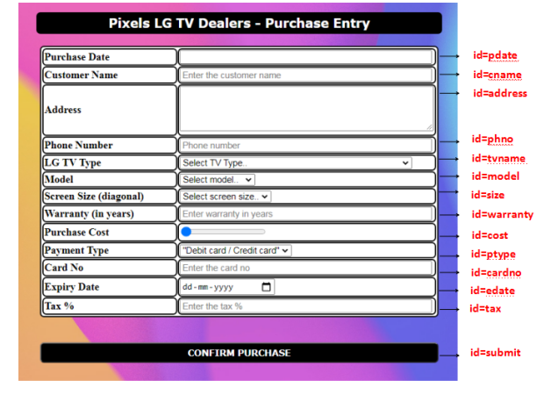

Payment Mode- Card: The screen shot of the Payment made through a card should look as given below:
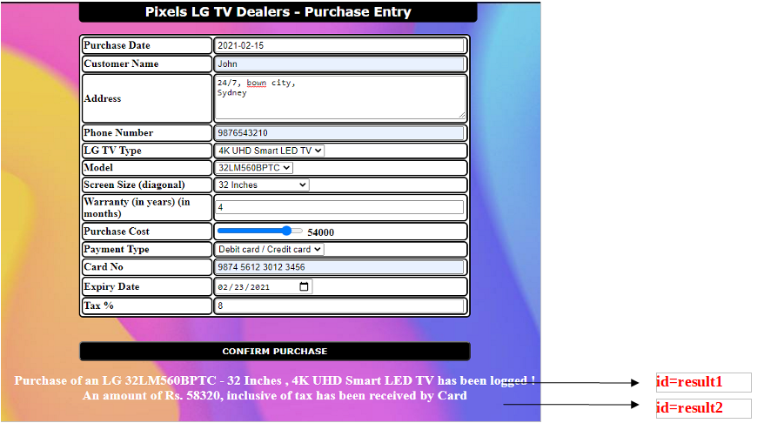
Payment Mode- Cash: The screen shot of the Payment made by cash should look as given below:
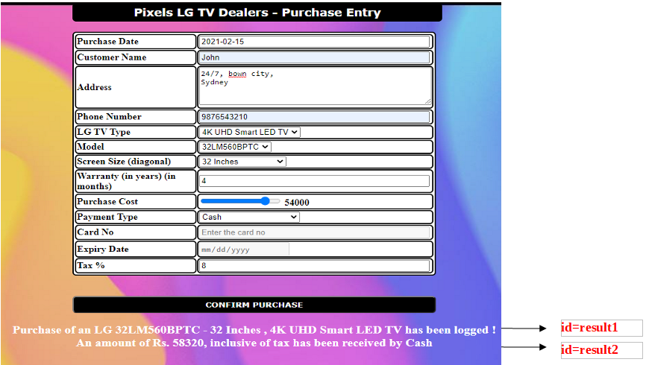
Use the Label Name and the Component Id as given. All the necessary attributes for the Components should be given.

Provide the details as given in the table below.
Req. # | Req. Name | Req. Description
1 | Design a Form“Pixels LG TV Dealers - Purchase Entry”with the specified fields. | NOTE: The text highlighted in bold in the Description needs to be implemented in the code to complete the form design.
  Label Name | Component Id  (Specify it for the “id” attribute) | Description
  Purchase Date | pdate | To get the current date filled in this field on focus.  Design Constraints:  Use the input type : “text”.  The field is mandatory.
  Customer Name | cname | To enter the customer name.  Design Constraints:  The text “Enter the customer name” should appear by default.  It should contain only alphabets and spaces.  The field is mandatory.
  Address | address | To enter the address.  Design Constraints:  The text “Enter the address” should appear by default.  Provide the correct tag and attributes to create a text area with 4 rows and 50 columns.  It should be mandatory.
  Phone Number | phno | To enter the phone number.  Design Constraints:  The text “Phone number” should appear by default.  Tip:  Use type=”tel”or Use type=”text” .  Use “pattern” attribute to accept the 10-digit mobile number to start with either of the following numbers: 7,8 or 9.  The field is mandatory.
  LG TV Type | tvname | To select the LG TV Type.  Design Constraints  Use the drop down box with “Select TV Type..”, “HD Ready TV”, ”LED HD-Ready TV”, “4K UHD Smart LED TV” and “LED Full HD TV” as the option values.  The field is mandatory.
  Model | model | To select the model.  Design Constraints  Use the drop down box with “Select model..”, “32LM560BPTC”, ”32LM636BPTB”, “55UM7300PTA” and “43LM5600PTC” as the option values.  The field is mandatory.
  Screen Size (diagonal) | size | To select the screen size.  Design Constraints  Use the drop down box with “Select screen size..”, “32 Inches”, ”55 Inches” and “43 Inches” as the option values.  The field is mandatory.
  Warranty (in years) | warranty | To enter the warranty.  Design Constraints:  The text “Enter warranty in years” should appear by default.  Provide the correct input type to make this component accept only a number.  The field is mandatory.
  Purchase Cost | cost | To select the purchase cost.  Design Constraints:  Provide the correct input type to make this component a range slider with min value 20000 and max value 60000.  It should be mandatory.
  Payment Type | ptype | To select the payment type.  Design Constraints  Use the drop down box with “Card” and “Cash” as the option values.  The field is mandatory.
  Card No | cardno | To enter the card number.  Design Constraints:  The text “Enter the card no” should appear by default.  Use “pattern” attribute for the field to accept 16 digit card number with spaces as in eg : 1234 5678 8765 4321
  Expiry Date | edate | To enter the expiry date.  Design Constraints:  The text “Enter the expiry date” should appear by default.  Provide the correct input type to make this component accept date.
  Tax % | tax | To enter the tax %.  Design Constraints:  Use the input type : “number”. The text “Enter the tax %” should appear by default.  The field is mandatory.
   | submit | Submit button to submit the form  Design Constraints  The input type should be “submit” with value “CONFIRM PURCHASE”
2 | Apply the mentioned styles using CSS to the components | STYLING WITH ELEMENT SELECTORS  - HEADING should be specified using <h3> tag.  Its text color must be #FFFFFF and the background color must be #000000.  The left margin must be 25% and right margin must be auto.  The text must be center aligned and width 50%.  The font family of the text must be Verdana.  The padding and border radius must be 5px and 6px respectively.  - TABLE , tr and td must be styled with width as 50% .  The left margin and right margin must be set to auto.  The border spacing and border radius must be 1px and 6px respectively.  Its text color must be #000000 and the background color must be #FFFFFF.  The padding must be 1px.  STYLING WITH ID SELECTOR  - SUBMIT component must be styled using it’s id as in :  Its text color must be #FFFFFF and the background color must be #000000.  The left margin must be 25% and right margin must be auto.  The padding must be 5px and width must be 50%.  The font family of the text must be Verdana and font weight must be bold.  The border radius must be 6px.  Note: Fill in the style tag so as to have the given styles applied to the components. (Do not use Inline CSS)
3 | Use JavaScript for filling in the current date. | The JavaScript function today() must get invoked on focusing on the purchase date field.  This method must fill-in the current date in the purchase date field.  Use the getElementById() function to set value into this field.
4 | Use JavaScript for displaying details pertaining to an LG TV purchase, inclusive of tax. | The JavaScript function display() must get invoked on clicking CONFIRM PURCHASE after making a valid purchase entry.  Hint: taxAmount=purchaseCost*(tax/100)  The function must calculate the total price (purchaseCost + taxAmount) and display the same.  Result statements must get displayed in a div tag as in :  "Purchase of an LG <Model> - <Screen Size> , <LG TV Type> has been logged ! " (display using div id result1)  "An amount of Rs. <Total>, inclusive of tax has been received by <Payment Type>” (display using div id result2)  Note:  Use Math.round() to get a rounded Total - which is the result of adding tax amount to the actual purchase cost.  Use the getElementById() function to retrieve the values.
5 | The form tag with attribute onsubmit | The form tag is already given in the code template. Do not change the code template and do the coding as per the requirements and specifications.  Make sure that the onsubmit attribute in the form tag invokes the JavaScript function as in "return display()". Also ensure that “return false;” statement is the last line of the JavaScript function “display()”.

